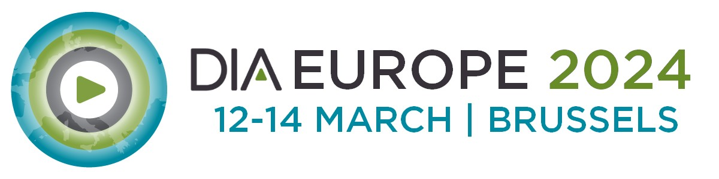

Justification Letter, In-Person Participation
Below, you'll find a "justification letter" template — a letter to your supervisor explaining all the benefits you'll get from attending the DIA Europe 2024 in-person, how the insights from the conference enhance your day-to-day work and help advancing your organization.
This general template will get you started while allowing you to customize it to you and your organization's particular needs.
<Date>
Dear <Supervisor’s name>,
I am seeking your support to attend DIA Europe Conference, 12-14 March 2024 in Brussels, Belgium.
This meeting brings together a unique community of life sciences professionals at all levels and across all disciplines, all with the common goal of fostering “Collaboration for Healthcare Innovation” that will lead to the development of safe and effective medical products and therapies to improve patient outcomes. Exclusive insights and discussions on neutral grounds make this conference special. The DIA Europe 2024 provides the greatest opportunity to meet with senior experts in drug development and especially regulators from around the world to expand networks for our organization. Attending the conference in person allows networking also in informal rounds and occasions.
An anticipated 1,500+ attendees, including industry professionals (from 200+ pharma companies), clinicians, 20+ patient organizations, 40+ regulatory agencies and 12+ payers and HTA bodies from more than 50 countries, will attend and present at this event. In addition, I will have access to the industry exhibition and networking activities and the on-demand content for 2 month after the event.
While attending this meeting, I will be able to participate in a number of interdisciplinary, cross-functional educational offerings with real world applications.

The conference programme was prepared by the distinguished programme committee in collaboration with DIA.
100+ sessions planned across 10 tracks featured ranging from:

<select interest areas applicable to you>

- Artificial Intelligence, Data Science RWE NEW
- Clinical Trials Development and Clinical Operations
- CMC & Product Quality
- Innovative Therapies, Precision Medicine & Diagnostics NEW
- International Collaboration & Regional Updates NEW
- Medical Devices and Combination Products
- Pharmacovigilance and Safety
- Professional Development
- Regulatory Operations
- Regulatory Strategy & EU Health Policy
- Value and Access

I am seeking your support in attending this meeting.
Registration Fee: Insert your registration fee from here
Estimated - Travel Expenses:
Estimated - Accommodation Expenses:
Other Expenses:

Thank you for taking the time to review this proposal. By attending DIA Europe 2023 having the opportunity to develop my skills, gain knowledge, and establish key contacts which will be a valuable investment for my profession, colleagues, and <insert name of your organization here>.
Sincerely,

